Friends and Family Test Results March and April 2026

Latest Results April 2026
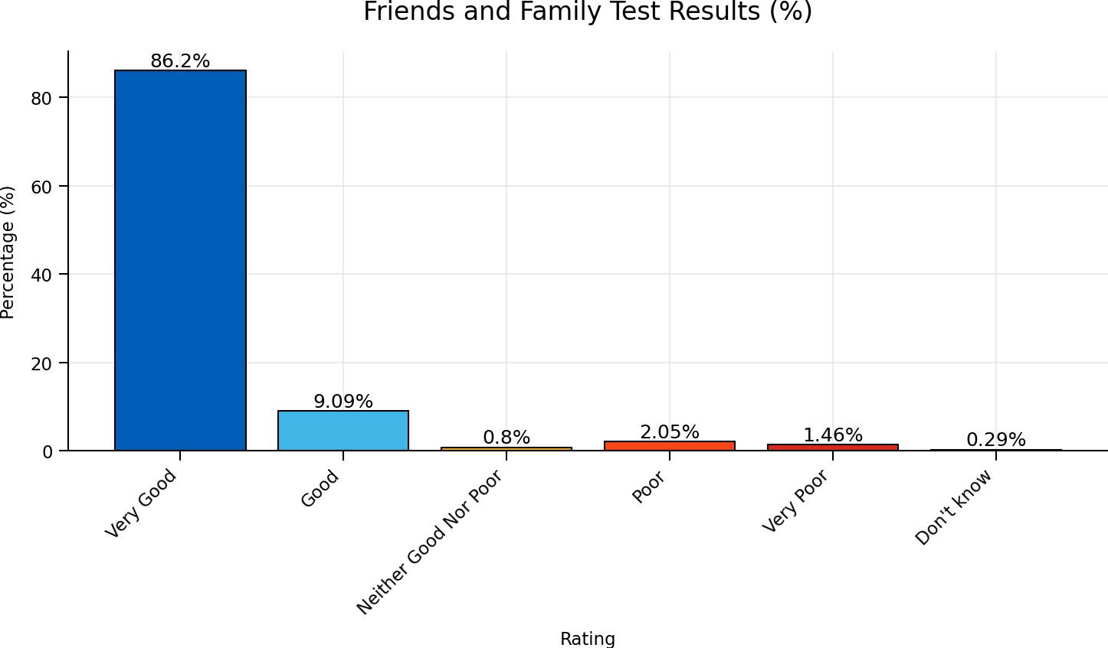

Friends and Family Test Results March 2026

March 2026 Results
